

Name of Student: Karan Kr. Pal PRN: 25070122098
Subject: Programming with Java Sem: III Batch:25-29
Assignment No: 5
TITLE: Develop a Java application demonstrating the use of Array List, Vector, and StringBuffer for dynamic data storage, management, and string manipulation.

Problem Statement
Develop a Java application demonstrating the use of Array List, Vector, and String Buffer for dynamic data storage, management, and string manipulation.

Learning Objectives
To implement dynamic data storage and string manipulation using Array List, Vector, and String Buffer.

Theory
ArrayList and Vector are dynamic array implementations provided by the Java Collections Framework. ArrayList offers faster performance in single-threaded applications, whereas Vector provides synchronized operations for thread safety. StringBuffer is a mutable sequence of characters that allows efficient string modification without creating new objects. These classes are commonly used in applications requiring dynamic memory allocation and efficient string processing.
- Create a To-Do List application using ArrayList to store tasks and StringBuffer to display tasks.

import java.util.ArrayList; class TodoList {
public static void main(String[] args) { ArrayList<String> tasks = new ArrayList<>();

tasks.add("Complete Java Assignment on Time"); tasks.add("Submit it");
tasks.add("Do Practice");

StringBuffer sb = new StringBuffer();

sb.append("To-Do List\n");

for (int i = 0; i < tasks.size(); i++) { sb.append((i + 1) + ". " + tasks.get(i) + "\n");
}

System.out.println(sb);
}
}

OUTPUT
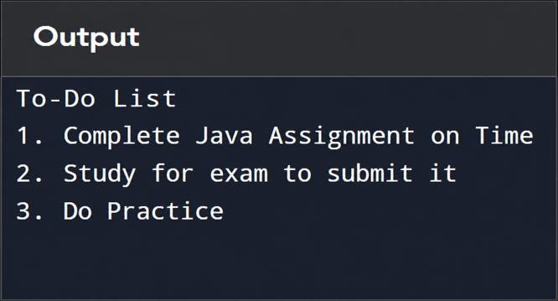

- Create a Student Course Registration System using ArrayList to store the list of courses registered by a student and StringBuffer to generate and display the

registered course list. The application should allow users to add, remove, and view registered courses.

import java.util.ArrayList; import java.util.Scanner;

class CourseRegistration {
public static void main(String[] args) { ArrayList<String> courses = new ArrayList<>(); Scanner sc = new Scanner(System.in);

int choice;

do {
System.out.println("\n1. Add Course"); System.out.println("2. Remove Course"); System.out.println("3. View Courses"); System.out.println("4. Exit"); System.out.print("Enter Choice: "); choice = sc.nextInt();
sc.nextLine();

switch (choice) { case 1:
System.out.print("Enter Course Name: ");

courses.add(sc.nextLine()); System.out.println("Course Added."); break;
case 2:
System.out.print("Enter Course Name to Remove: "); String course = sc.nextLine();
if (courses.remove(course)) System.out.println("Course Removed.");
else
System.out.println("Course Not Found."); break;
case 3:
StringBuffer sb = new StringBuffer(); sb.append("Registered Courses\n"); for (int i = 0; i < courses.size(); i++) {
sb.append((i + 1) + ". " + courses.get(i) + "\n");
}
System.out.println(sb); break;
case 4:
System.out.println("Exiting..."); break;

default:

System.out.println("Invalid Choice.");
}
} while (choice != 4);

sc.close();
}
}

OUTPUT
